

Vietnamese Study System for Japanese

DETAIL DESIGN DOCUMENT

Class Design

**Project Code: Veazy**

**Document Code: Veazy_Class Design_v1.0_EN**

**Hoa Lac, 31/07/2016**

Record of change

*A - Added M - Modified D – Deleted

|  |  |  |  |  |
| --- | --- | --- | --- | --- |
| **Effective Date** | **Changed Items** | **A* M, D** | **Change Description** | **New Version** |
| 31/07/2016 | Add new | A |  | V1.0 |
|  |  |  |  |  |
|  |  |  |  |  |
|  |  |  |  |  |
|  |  |  |  |  |
|  |  |  |  |  |
|  |  |  |  |  |
|  |  |  |  |  |
|  |  |  |  |  |
|  |  |  |  |  |
|  |  |  |  |  |

SIGNATURE PAGE

**ORIGINATOR:** Dao Thanh Tung 30/07/2016

Developer

**REVIEWERS:**

**APPROVAL:** Nguyen Van Sang

Supervisor

TABLE OF CONTENTS

1 Introduction 6

1.1 Purpose 6

1.2 Definitions, Acronyms and Abbreviations 6

2 Packages 7

2.1 User Package 8

2.1.1 Class diagram 8

2.1.2 Model_User class 9

2.1.3 UserController class 9

2.2 Admin Package 10

2.2.1 Class diagram 10

2.2.2 Model_User class 11

2.2.3 Model_Vocabulary class 12

2.2.4 Model_Grammar class 13

2.2.5 Model_Kanji class 14

2.2.6 Model_Sentence class 14

2.2.7 Model_Video class 15

2.2.8 Model_TrainingListening class 15

2.2.9 Model_ReadingDocument class 15

2.2.10 Model_Contact class 15

2.2.11 Model_Conversation class 15

2.2.12 Model_Test class 15

2.3 Vocabulary Package 16

2.3.1 Class diagram 16

2.3.2 Model_Vocabulary class 17

2.3.3 VocabularyController class 18

2.4 Grammar Package 18

2.4.1 Class diagram 18

2.4.2 Model_Grammar class 19

2.4.3 GrammarController class 20

2.5 Kanji Package 20

2.5.1 Class diagram 20

2.5.2 Model_Kanji class 21

2.5.3 KanjiController class 21

2.6 ReadingDocument Package 22

2.6.1 22

2.7 TrainingListening Package 22

2.7.1 Class diagram 22

2.7.2 Model_TraniningListening class 23

2.7.3 TrainingListeningController 23

2.8 Video Package 24

2.8.1 Class diagram 24

2.8.2 Model_Video class 25

2.8.3 VideoController 25

2.9 Contact Package 26

2.9.1 Class diagram 26

2.9.2 Model_Contact class 26

2.9.3 ContactController 27

2.10 Sentence Package 28

2.10.1 Class diagram 28

2.10.2 Model_Sentence class 29

2.10.3 SentenceController 29

2.11 Conversation Package 30

2.11.1 Class diagram 30

2.11.2 Model_Conversation class 31

2.11.3 ConversationController 31

2.12 Test Package 32

2.12.1 Class diagram 32

2.12.2 Model_Test class 33

2.12.3 TestController 34

3 MVC model 35

# Introduction

## Purpose

Vietnamese Study System for Japanese class design document contains descriptions of all classes of the Vietnamese Study System for Japanese system. It includes:

* Class diagrams that describe the static relation of all classes in the system.

## Definitions, Acronyms and Abbreviations

|  |  |  |
| --- | --- | --- |
| Abbreviations | Description | Comment |
| MVC | Model View Control model |  |

# D:\Documents\GitHub\DATN\201605JS01\WIP\Users\TungDT\Class Diagram\Package.pngPackages

**Figure 0: List Packages**

|  |  |  |  |
| --- | --- | --- | --- |
| No | Package | Language | Description |
| 1. 01 | core | JAVA | Contains classes related to core function |
|  | dictionary | JAVA | Contain classes related to dictionary |
|  | common | JAVA |  |
|  | controller | JAVA | Contain web controller |
|  | dao | JAVA | Contain data access object |
|  | exception | JAVA | Contain defined exception |
|  | form | JAVA | Contain defined web form |
|  | model | JAVA | Contain model class |
|  | response | JAVA | Contain response model class |
|  | security | JAVA | Contain classes related security |
|  | service | JAVA | Contain web service |

## core.common Package

### Class diagram

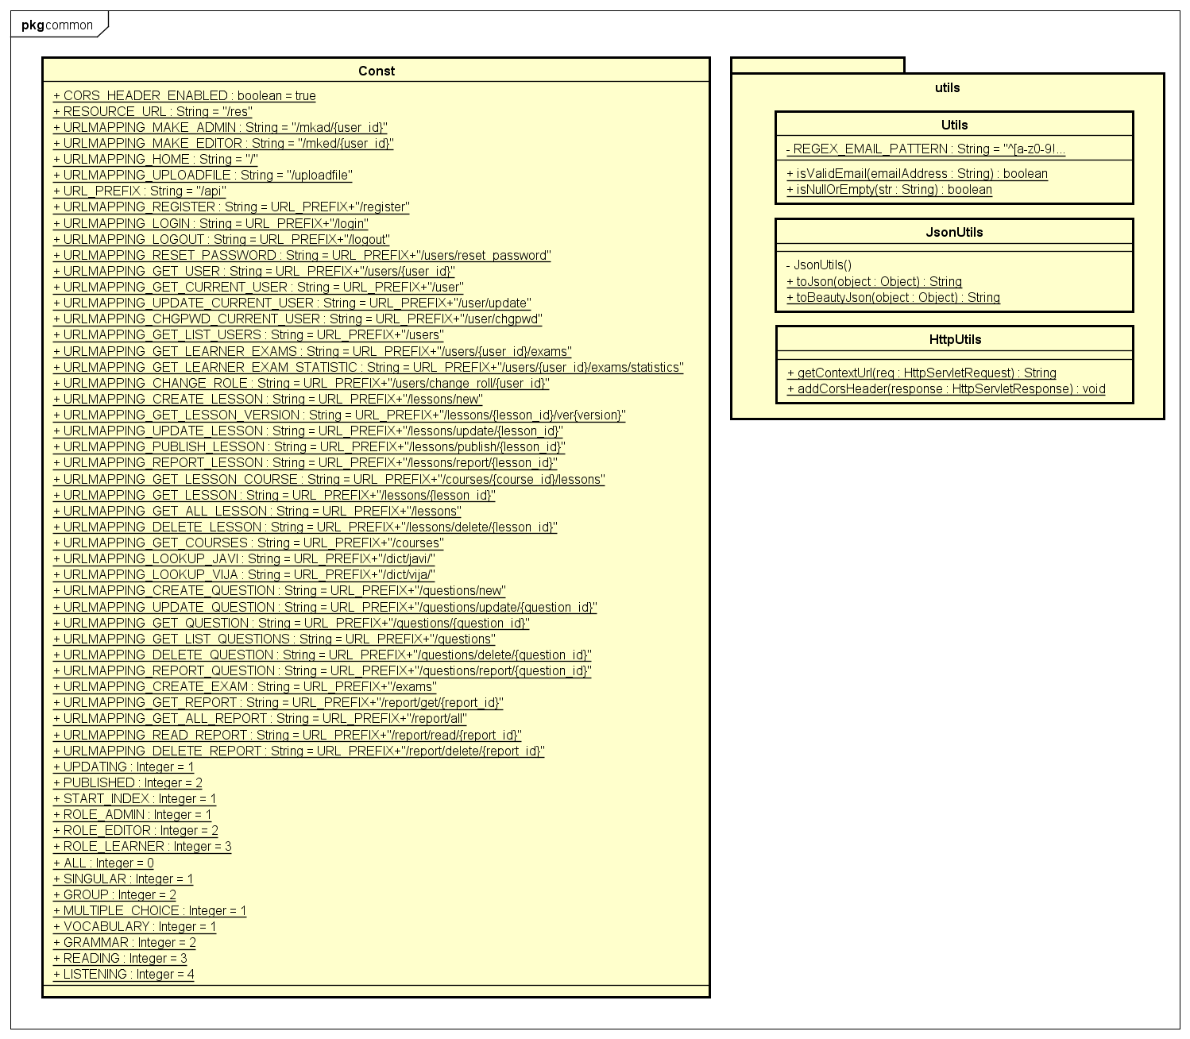

**Figure 1: Class diagram core.common package**

|  |  |  |
| --- | --- | --- |
| No | Class Name | Description |
| 1 | Const | Contain constant variable |
| 2 | Utils | Contain common utility function |
| 3 | JsonUtils | Contain utility function about json |
| 4 | HttpUtils | Contain utility function about http |

### Const class

#### Attributes

|  |  |  |  |
| --- | --- | --- | --- |
| No | Attribute | Type | Value |
| 1. 1 | CORS_HEADER_ENABLED | boolean | true |
| 1. 2 | RESOURCE_URL | String | /res |
| 1. 3 | URLMAPPING_MAKE_ADMIN | String | /mkad/{user_id} |
| 1. 3 | URLMAPPING_MAKE_EDITOR | String | /mked/{user_id} |
|  | URLMAPPING_HOME | String | / |
|  | URLMAPPING_UPLOADFILE | String | /uploadfile |
|  | URL_PREFIX | String | /api |
|  | URLMAPPING_REGISTER | String | URL_PREFIX + /register |
|  | URLMAPPING_LOGIN | String | URL_PREFIX + /login |
|  | URLMAPPING_LOGOUT | String | URL_PREFIX + /logout |
|  | URLMAPPING_RESET_PASSWORD | String | URL_PREFIX + /users/reset_password |
|  | URLMAPPING_GET_USER | String | URL_PREFIX + /users/{user_id} |
|  | URLMAPPING_GET_CURRENT_USER | String | URL_PREFIX + /user |
|  | URLMAPPING_UPDATE_CURRENT_USER | String | URL_PREFIX + /user/update |
|  | URLMAPPING_CHGPWD_CURRENT_USER | String | URL_PREFIX + /user/chgpwd |
|  | URLMAPPING_GET_LIST_USERS | String | URL_PREFIX + /users |
|  | URLMAPPING_GET_LEARNER_EXAMS | String | URL_PREFIX + /users/{user_id}/exams |
|  | URLMAPPING_GET_LEARNER_EXAM_STATISTIC | String | URL_PREFIX + /users/{user_id}/exams/statistics |
|  | URLMAPPING_CHANGE_ROLE | String | URL_PREFIX + /users/change_roll/{user_id} |
|  | URLMAPPING_CREATE_LESSON | String | URL_PREFIX + /lessons/new |
|  | URLMAPPING_GET_LESSON_VERSION | String | URL_PREFIX + /lessons/{lesson_id}/ver{version} |
|  | URLMAPPING_UPDATE_LESSON | String | URL_PREFIX + /lessons/update/{lesson_id} |
|  | URLMAPPING_PUBLISH_LESSON | String | URL_PREFIX + /lessons/publish/{lesson_id} |
|  | URLMAPPING_REPORT_LESSON | String | URL_PREFIX + /lessons/report/{lesson_id} |
|  | URLMAPPING_GET_LESSON_COURSE | String | URL_PREFIX + /courses/{course_id}/lessons |
|  | URLMAPPING_GET_LESSON | String | URL_PREFIX + /lessons/{lesson_id} |
|  | URLMAPPING_GET_ALL_LESSON | String | URL_PREFIX + /lessons |
|  | URLMAPPING_DELETE_LESSON | String | URL_PREFIX + /lessons/delete/{lesson_id} |
|  | URLMAPPING_GET_COURSES | String | URL_PREFIX + /courses |
|  | URLMAPPING_LOOKUP_JAVI | String | URL_PREFIX + /dict/javi/ |
|  | URLMAPPING_LOOKUP_VIJA | String | URL_PREFIX + /dict/vija/ |
|  | URLMAPPING_CREATE_QUESTION | String | URL_PREFIX + /questions/new |
|  | URLMAPPING_UPDATE_QUESTION | String | URL_PREFIX + /questions/update/{question_id} |
|  | URLMAPPING_GET_QUESTION | String | URL_PREFIX + /questions/{question_id} |
|  | URLMAPPING_GET_LIST_QUESTIONS | String | URL_PREFIX + /questions |
|  | URLMAPPING_DELETE_QUESTION | String | URL_PREFIX + /questions/delete/{question_id} |
|  | URLMAPPING_REPORT_QUESTION | String | URL_PREFIX + /questions/report/{question_id} |
|  | URLMAPPING_CREATE_EXAM | String | URL_PREFIX + /exams |
|  | URLMAPPING_GET_REPORT | String | URL_PREFIX + /report/get/{report_id} |
|  | URLMAPPING_GET_ALL_REPORT | String | URL_PREFIX + /report/all |
|  | URLMAPPING_READ_REPORT | String | URL_PREFIX + /report/read/{report_id} |
|  | URLMAPPING_DELETE_REPORT | String | URL_PREFIX + /report/delete/{report_id} |
|  | UPDATING | Integer | 1 |
|  | PUBLISHED | Integer | 2 |
|  | START_INDEX | Integer | 1 |
|  | ROLE_ADMIN | Integer | 1 |
|  | ROLE_EDITOR | Integer | 2 |
|  | ROLE_LEARNER | Integer | 3 |
|  | ALL | Integer | 0 |
|  | SINGULAR | Integer | 1 |
|  | GROUP | Integer | 2 |
|  | MULTIPLE_CHOICE | Integer | 1 |
|  | VOCABULARY | Integer | 1 |
|  | GRAMMAR | Integer | 2 |
|  | READING | Integer | 3 |
|  | LISTENING | Integer | 4 |

### Utils class

#### Attributes

|  |  |  |  |  |  |
| --- | --- | --- | --- | --- | --- |
| No | Attribute | Type | Default | Note | Description |
| 1 | REGEX_EMAIL_PATTERN | String |  | private | Regex pattern to determine an email |

#### Methods

|  |  |  |
| --- | --- | --- |
| No | Method | Description |
| 1 | isValidEmail() | Check if a string is a valid email or not. |
| 2 | isNullOrEmpty() | Check if a string is null or empty. |

### JsonUtils class

#### Attributes

|  |  |  |  |  |  |
| --- | --- | --- | --- | --- | --- |
| No | Attribute | Type | Default | Note | Description |
|  |  |  |  |  |  |

#### Methods

|  |  |  |
| --- | --- | --- |
| No | Method | Description |
| 1 | toJson() | Convert an object to a json format |
| 2 | toBeautyJson() | Convert an object to a beautiful json format |

### HttpUtils Class

#### Attributes

|  |  |  |  |  |  |
| --- | --- | --- | --- | --- | --- |
| No | Attribute | Type | Default | Note | Description |
| 1 |  |  |  |  |  |

#### Methods

|  |  |  |
| --- | --- | --- |
| No | Method | Description |
| 1 | getContextUrl() |  |
| 2 | addCorsHeader() |  |

### Common Sequence Diagram

## core.controller Package

### Class diagram

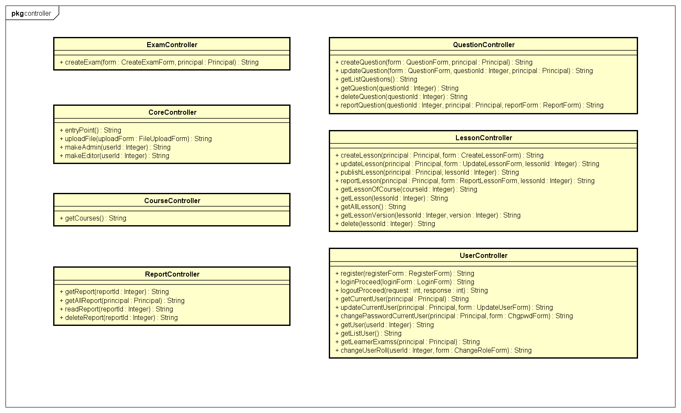

**Figure 2: Class diagram core.controller package**

|  |  |  |
| --- | --- | --- |
| No | Class Name | Description |
| 1 | CoreController |  |
| 2 | CourseController |  |
| 3 | ExamController |  |
| 4 | LessonController |  |
| 5 | QuestionController |  |
| 6 | ReportController |  |
| 7 | UserController |  |

### CoreController Class

#### Attributes

|  |  |  |  |  |  |
| --- | --- | --- | --- | --- | --- |
| No | Attribute | Type | Default | Note | Description |
| 1 |  |  |  |  |  |

#### Methods

|  |  |  |
| --- | --- | --- |
| No | Method | Description |
| 1 | entryPoint() |  |
| 2 | uploadFile() |  |
| 3 | makeAdmin() |  |
| 4 | makeEditor() |  |

### CourseController Class

#### Attributes

|  |  |  |  |  |  |
| --- | --- | --- | --- | --- | --- |
| No | Attribute | Type | Default | Note | Description |
| 1 |  |  |  |  |  |

#### Methods

|  |  |  |
| --- | --- | --- |
| No | Method | Description |
| 1 | getCourses() |  |

### ExamController Class

#### Attributes

|  |  |  |  |  |  |
| --- | --- | --- | --- | --- | --- |
| No | Attribute | Type | Default | Note | Description |
| 1 |  |  |  |  |  |

#### Methods

|  |  |  |
| --- | --- | --- |
| No | Method | Description |
| 1 | createExam () |  |

### LessonController Class

#### Attributes

|  |  |  |  |  |  |
| --- | --- | --- | --- | --- | --- |
| No | Attribute | Type | Default | Note | Description |
| 1 |  |  |  |  |  |

#### Methods

|  |  |  |
| --- | --- | --- |
| No | Method | Description |
| 1 | createLesson () |  |
| 2 | updateLesson () |  |
| 3 | publishLesson () |  |
| 4 | reportLesson () |  |
| 5 | getLessonOfCourse () |  |
| 6 | getLesson () |  |
| 7 | getAllLesson () |  |
| 8 | getLessonVersion () |  |
| 9 | delete () |  |

### QuestionController Class

#### Attributes

|  |  |  |  |  |  |
| --- | --- | --- | --- | --- | --- |
| No | Attribute | Type | Default | Note | Description |
| 1 |  |  |  |  |  |

#### Methods

|  |  |  |
| --- | --- | --- |
| No | Method | Description |
| 1 | createQuestion () |  |
| 2 | updateQuestion () |  |
| 3 | getListQuestions () |  |
| 4 | getQuestion () |  |
| 5 | deleteQuestion() |  |
| 6 | reportQuestion() |  |

### ReportController Class

#### Attributes

|  |  |  |  |  |  |
| --- | --- | --- | --- | --- | --- |
| No | Attribute | Type | Default | Note | Description |
| 1 |  |  |  |  |  |

#### Methods

|  |  |  |
| --- | --- | --- |
| No | Method | Description |
| 1 | getReport () |  |
| 2 | getAllReport () |  |
| 3 | readReport () |  |
| 4 | deleteReport () |  |

### UserController Class

#### Attributes

|  |  |  |  |  |  |
| --- | --- | --- | --- | --- | --- |
| No | Attribute | Type | Default | Note | Description |
| 1 |  |  |  |  |  |

#### Methods

|  |  |  |
| --- | --- | --- |
| No | Method | Description |
| 1 | register () |  |
| 2 | loginProceed () |  |
| 3 | logoutProceed () |  |
| 4 | getCurrentUser () |  |
| 5 | updateCurrentUser() |  |
| 6 | changePasswordCurrentUser() |  |
| 7 | getUser() |  |
| 8 | getListUser() |  |
| 9 | getLearnerExamss() |  |
| 10 | changeUserRoll() |  |

### Sequence Diagram

## core.dao Package

### Class diagram

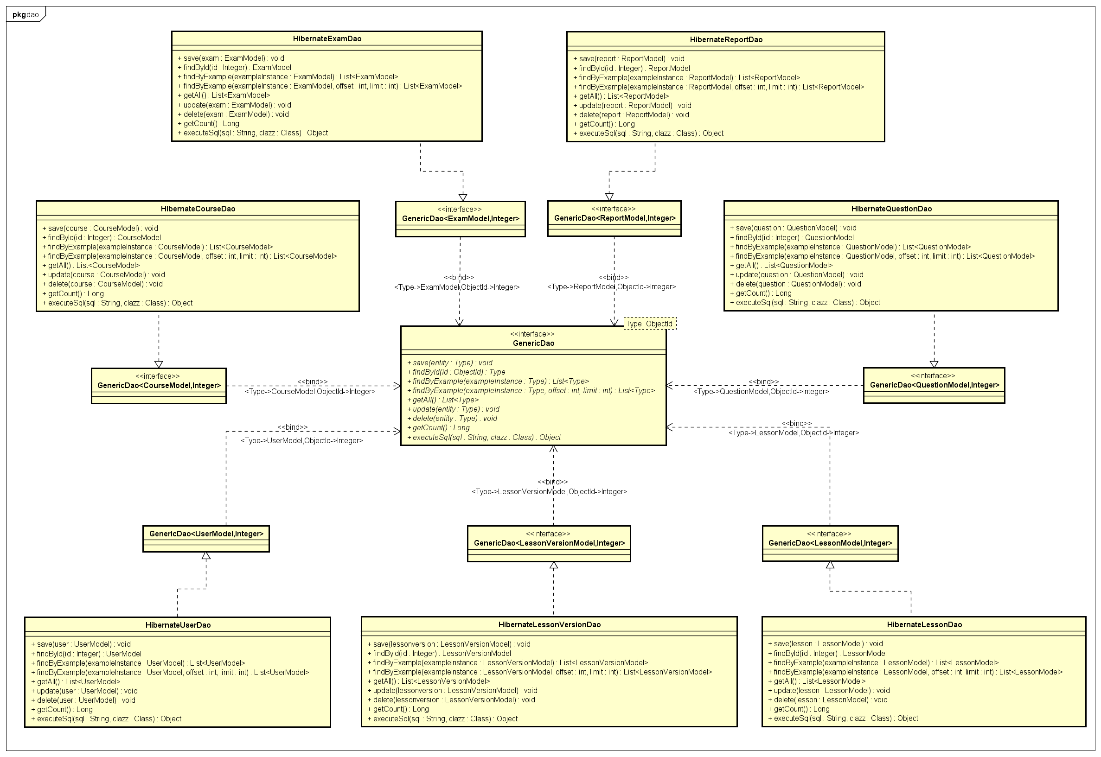

**Figure 3: Class diagram core.dao package**

|  |  |  |
| --- | --- | --- |
| No | Class Name | Description |
| 1 | HibernateCourseDao |  |
| 2 | HibernateExamDao |  |
| 3 | HibernateLessonDao |  |
| 4 | HibernateLessonVersionDao |  |
| 5 | HibernateQuestionDao |  |
| 6 | HibernateReportDao |  |
| 7 | HibernateUserDao |  |

### HibernateCourseDao Class

#### Attributes

|  |  |  |  |  |  |
| --- | --- | --- | --- | --- | --- |
| No | Attribute | Type | Default | Note | Description |
| 1 |  |  |  |  |  |

#### Methods

|  |  |  |
| --- | --- | --- |
| No | Method | Description |
| 1 | save() |  |
| 2 | findById() |  |
| 3 | findByExample() |  |
| 4 | findByExample() |  |
| 5 | getAll() |  |
| 6 | update() |  |
| 7 | delete() |  |
| 8 | getCount() |  |
| 9 | executeSql() |  |

### HibernateExamDao Class

#### Attributes

|  |  |  |  |  |  |
| --- | --- | --- | --- | --- | --- |
| No | Attribute | Type | Default | Note | Description |
| 1 |  |  |  |  |  |

#### Methods

|  |  |  |
| --- | --- | --- |
| No | Method | Description |
| 1 | save() |  |
| 2 | findById() |  |
| 3 | findByExample() |  |
| 4 | findByExample() |  |
| 5 | getAll() |  |
| 6 | update() |  |
| 7 | delete() |  |
| 8 | getCount() |  |
| 9 | executeSql() |  |

### HibernateLessonDao Class

#### Attributes

|  |  |  |  |  |  |
| --- | --- | --- | --- | --- | --- |
| No | Attribute | Type | Default | Note | Description |
| 1 |  |  |  |  |  |

#### Methods

|  |  |  |
| --- | --- | --- |
| No | Method | Description |
| 1 | save() |  |
| 2 | findById() |  |
| 3 | findByExample() |  |
| 4 | findByExample() |  |
| 5 | getAll() |  |
| 6 | update() |  |
| 7 | delete() |  |
| 8 | getCount() |  |
| 9 | executeSql() |  |

### HibernateLessonVersionDao Class

#### Attributes

|  |  |  |  |  |  |
| --- | --- | --- | --- | --- | --- |
| No | Attribute | Type | Default | Note | Description |
| 1 |  |  |  |  |  |

#### Methods

|  |  |  |
| --- | --- | --- |
| No | Method | Description |
| 1 | save() |  |
| 2 | findById() |  |
| 3 | findByExample() |  |
| 4 | findByExample() |  |
| 5 | getAll() |  |
| 6 | update() |  |
| 7 | delete() |  |
| 8 | getCount() |  |
| 9 | executeSql() |  |

### HibernateQuestionDao Class

#### Attributes

|  |  |  |  |  |  |
| --- | --- | --- | --- | --- | --- |
| No | Attribute | Type | Default | Note | Description |
| 1 |  |  |  |  |  |

#### Methods

|  |  |  |
| --- | --- | --- |
| No | Method | Description |
| 1 | save() |  |
| 2 | findById() |  |
| 3 | findByExample() |  |
| 4 | findByExample() |  |
| 5 | getAll() |  |
| 6 | update() |  |
| 7 | delete() |  |
| 8 | getCount() |  |
| 9 | executeSql() |  |

### HibernateReportDao Class

#### Attributes

|  |  |  |  |  |  |
| --- | --- | --- | --- | --- | --- |
| No | Attribute | Type | Default | Note | Description |
| 1 |  |  |  |  |  |

#### Methods

|  |  |  |
| --- | --- | --- |
| No | Method | Description |
| 1 | save() |  |
| 2 | findById() |  |
| 3 | findByExample() |  |
| 4 | findByExample() |  |
| 5 | getAll() |  |
| 6 | update() |  |
| 7 | delete() |  |
| 8 | getCount() |  |
| 9 | executeSql() |  |

### HibernateUserDao Class

#### Attributes

|  |  |  |  |  |  |
| --- | --- | --- | --- | --- | --- |
| No | Attribute | Type | Default | Note | Description |
| 1 |  |  |  |  |  |

#### Methods

|  |  |  |
| --- | --- | --- |
| No | Method | Description |
| 1 | save() |  |
| 2 | findById() |  |
| 3 | findByExample() |  |
| 4 | findByExample() |  |
| 5 | getAll() |  |
| 6 | update() |  |
| 7 | delete() |  |
| 8 | getCount() |  |
| 9 | executeSql() |  |

### Sequence diagram

## core.exception Package

### Class diagram

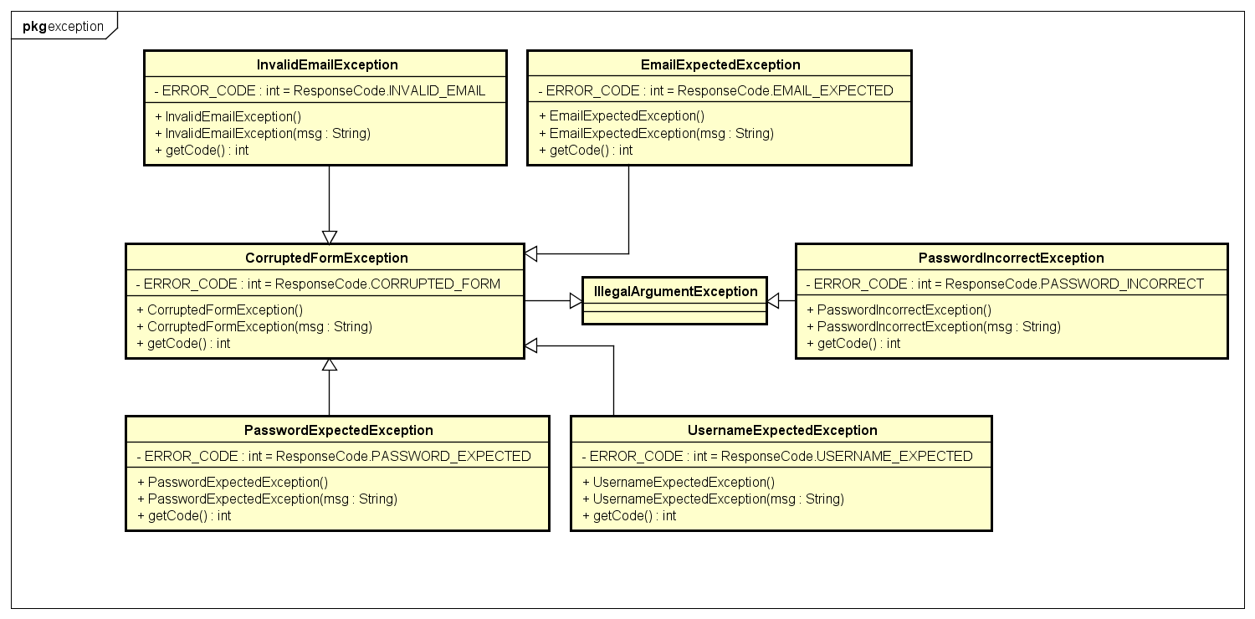

***Figure 4: Class diagram Practice core.exception package***

|  |  |  |
| --- | --- | --- |
| No | Class Name | Description |
| 1 | CorruptedFormException |  |
| 2 | EmailExpectedException |  |
| 3 | InvalidEmailException |  |
| 4 | PasswordExpectedException |  |
| 5 | PasswordIncorrectException |  |
|  | UsernameExpectedException |  |

### CorruptedFormException Class

#### Attributes

|  |  |  |  |  |  |
| --- | --- | --- | --- | --- | --- |
| No | Attribute | Type | Default | Note | Description |
| 1 | ERROR_CODE | int |  | private |  |

#### Methods

|  |  |  |
| --- | --- | --- |
| No | Method | Description |
| 1 | getCode() |  |

### EmailExpectedException Class

#### Attributes

|  |  |  |  |  |  |
| --- | --- | --- | --- | --- | --- |
| No | Attribute | Type | Default | Note | Description |
| 1 | ERROR_CODE | int |  | private |  |

#### Methods

|  |  |  |
| --- | --- | --- |
| No | Method | Description |
| 1 | getCode() |  |

### InvalidEmailException Class

#### Attributes

|  |  |  |  |  |  |
| --- | --- | --- | --- | --- | --- |
| No | Attribute | Type | Default | Note | Description |
| 1 | ERROR_CODE | int |  | private |  |

#### Methods

|  |  |  |
| --- | --- | --- |
| No | Method | Description |
| 1 | getCode() |  |

### PasswordExpectedException Class

#### Attributes

|  |  |  |  |  |  |
| --- | --- | --- | --- | --- | --- |
| No | Attribute | Type | Default | Note | Description |
| 1 | ERROR_CODE | int |  | private |  |

#### Methods

|  |  |  |
| --- | --- | --- |
| No | Method | Description |
| 1 | getCode() |  |

### PasswordIncorrectException Class

#### Attributes

|  |  |  |  |  |  |
| --- | --- | --- | --- | --- | --- |
| No | Attribute | Type | Default | Note | Description |
| 1 | ERROR_CODE | int |  | private |  |

#### Methods

|  |  |  |
| --- | --- | --- |
| No | Method | Description |
| 1 | getCode() |  |

### UsernameExpectedException Class

#### Attributes

|  |  |  |  |  |  |
| --- | --- | --- | --- | --- | --- |
| No | Attribute | Type | Default | Note | Description |
| 1 | ERROR_CODE | int |  | private |  |

#### Methods

|  |  |  |
| --- | --- | --- |
| No | Method | Description |
| 1 | getCode() |  |

### Sequence Diagram

## core.form Package

### Class diagram

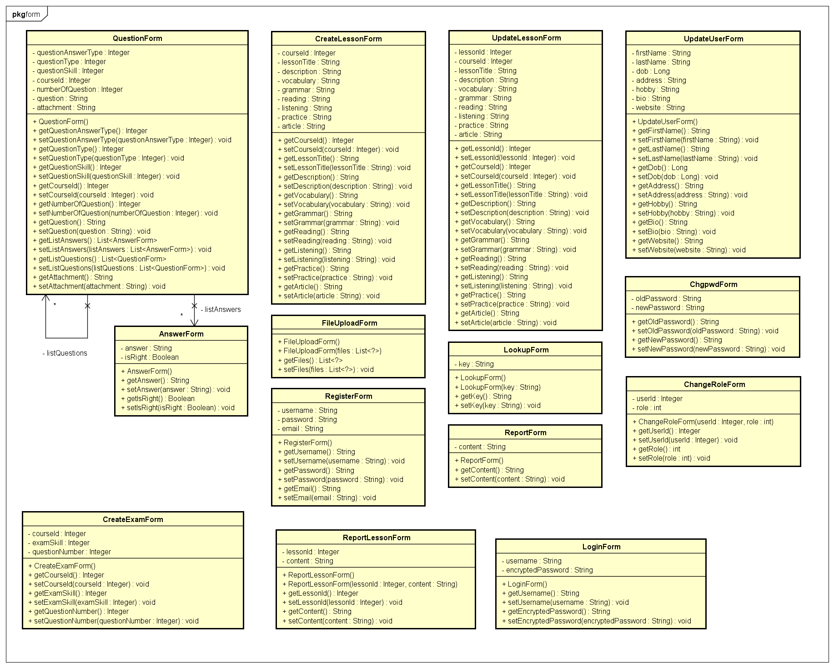

**Figure 5: Class diagram core.form package**

|  |  |  |
| --- | --- | --- |
| No | Class Name | Description |
| 1 | AnswerForm |  |
| 2 | ChangeRoleForm |  |
| 3 | ChgpwdForm |  |
| 4 | CreateExamForm |  |
| 5 | CreateLessonForm |  |
| 6 | FileUploadForm |  |
| 7 | LoginForm |  |
| 8 | LookupForm |  |
| 9 | QuestionForm |  |
| 10 | RegisterForm |  |
| 11 | ReportForm |  |
| 12 | ReportLessonForm |  |
| 13 | UpdateLessonForm |  |
| 14 | UpdateUserForm |  |

### AnswerForm Class

#### Attributes

|  |  |  |  |  |  |
| --- | --- | --- | --- | --- | --- |
| No | Attribute | Type | Default | Note | Description |
| 1 | answer | String |  | private |  |
| 2 | isRight | Boolean |  | private |  |

#### Methods

|  |  |  |
| --- | --- | --- |
| No | Method | Description |
| 1 |  |  |

### ChangeRoleForm Class

#### Attributes

|  |  |  |  |  |  |
| --- | --- | --- | --- | --- | --- |
| No | Attribute | Type | Default | Note | Description |
| 1 | userId | Integer |  | private |  |
| 2 | role | Integer |  | private |  |

#### Methods

|  |  |  |
| --- | --- | --- |
| No | Method | Description |
| 1 |  |  |

### ChgpwdForm Class

#### Attributes

|  |  |  |  |  |  |
| --- | --- | --- | --- | --- | --- |
| No | Attribute | Type | Default | Note | Description |
| 1 | oldPassword | String |  | private |  |
| 2 | newPassword | String |  | private |  |

#### Methods

|  |  |  |
| --- | --- | --- |
| No | Method | Description |
| 1 |  |  |

### CreateExamForm Class

#### Attributes

|  |  |  |  |  |  |
| --- | --- | --- | --- | --- | --- |
| No | Attribute | Type | Default | Note | Description |
| 1 | courseId | Integer |  | private |  |
| 2 | examSkill | Integer |  | private |  |
| 3 | questionNumber | Integer |  | private |  |

#### Methods

|  |  |  |
| --- | --- | --- |
| No | Method | Description |
| 1 |  |  |

### CreateLessonForm Class

#### Attributes

|  |  |  |  |  |  |
| --- | --- | --- | --- | --- | --- |
| No | Attribute | Type | Default | Note | Description |
| 1 | courseId | Integer |  | private |  |
| 2 | lessonTitle | String |  | private |  |
| 3 | description | String |  | private |  |
| 4 | vocabulary | String |  | private |  |
| 5 | grammar | String |  | private |  |
| 6 | reading | String |  | private |  |
| 7 | listening | String |  | private |  |
| 8 | practice | String |  | private |  |
| 9 | article | String |  | private |  |

#### Methods

|  |  |  |
| --- | --- | --- |
| No | Method | Description |
| 1 |  |  |

### FileUploadForm Class

#### Attributes

|  |  |  |  |  |  |
| --- | --- | --- | --- | --- | --- |
| No | Attribute | Type | Default | Note | Description |
| 1 |  |  |  |  |  |

#### Methods

|  |  |  |
| --- | --- | --- |
| No | Method | Description |
| 1 |  |  |

### LoginForm Class

#### Attributes

|  |  |  |  |  |  |
| --- | --- | --- | --- | --- | --- |
| No | Attribute | Type | Default | Note | Description |
| 1 | username | String |  | private |  |
| 2 | encryptedPassword | String |  | private |  |

#### Methods

|  |  |  |
| --- | --- | --- |
| No | Method | Description |
| 1 |  |  |

### LookupForm Class

#### Attributes

|  |  |  |  |  |  |
| --- | --- | --- | --- | --- | --- |
| No | Attribute | Type | Default | Note | Description |
| 1 | key | String |  | private |  |

#### Methods

|  |  |  |
| --- | --- | --- |
| No | Method | Description |
| 1 |  |  |

### QuestionForm Class

#### Attributes

|  |  |  |  |  |  |
| --- | --- | --- | --- | --- | --- |
| No | Attribute | Type | Default | Note | Description |
| 1 | questionAnswerType | Integer |  | private |  |
| 2 | questionType | Integer |  | private |  |
| 3 | questionSkill | Integer |  | private |  |
| 4 | courseId | Integer |  | private |  |
| 5 | numberOfQuestion | Integer |  | private |  |
| 6 | question | String |  | private |  |
| 7 | attachment | String |  | private |  |

#### Methods

|  |  |  |
| --- | --- | --- |
| No | Method | Description |
| 1 |  |  |

### RegisterForm Class

#### Attributes

|  |  |  |  |  |  |
| --- | --- | --- | --- | --- | --- |
| No | Attribute | Type | Default | Note | Description |
| 1 | username | String |  | private |  |
| 2 | password | String |  | private |  |
| 3 | email | String |  | private |  |

#### Methods

|  |  |  |
| --- | --- | --- |
| No | Method | Description |
| 1 |  |  |

### ReportForm Class

#### Attributes

|  |  |  |  |  |  |
| --- | --- | --- | --- | --- | --- |
| No | Attribute | Type | Default | Note | Description |
| 1 | content | String |  | private |  |

#### Methods

|  |  |  |
| --- | --- | --- |
| No | Method | Description |
| 1 |  |  |

### ReportLessonForm Class

#### Attributes

|  |  |  |  |  |  |
| --- | --- | --- | --- | --- | --- |
| No | Attribute | Type | Default | Note | Description |
| 1 | lessonID | Integer |  | private |  |
| 2 | content | String |  | private |  |

#### Methods

|  |  |  |
| --- | --- | --- |
| No | Method | Description |
| 1 |  |  |

### UpdateLessonForm Class

#### Attributes

|  |  |  |  |  |  |
| --- | --- | --- | --- | --- | --- |
| No | Attribute | Type | Default | Note | Description |
| 1 | lessonId | Integer |  | private |  |
| 2 | courseId | Integer |  | private |  |
| 3 | lessonTitle | String |  | private |  |
| 4 | description | String |  | private |  |
| 5 | vocabulary | String |  | private |  |
| 6 | grammar | String |  | private |  |
| 7 | reading | String |  | private |  |
| 8 | listening | String |  | private |  |
| 9 | practice | String |  | private |  |
| 10 | article | String |  | private |  |

#### Methods

|  |  |  |
| --- | --- | --- |
| No | Method | Description |
| 1 |  |  |

### UpdateUserForm Class

#### Attributes

|  |  |  |  |  |  |
| --- | --- | --- | --- | --- | --- |
| No | Attribute | Type | Default | Note | Description |
| 1 | firstName | String |  | private |  |
| 2 | lastName | String |  | private |  |
| 3 | dob | Long |  | private |  |
| 4 | address | String |  | private |  |
| 5 | hobby | String |  | private |  |
| 6 | bio | String |  | private |  |
| 7 | website | String |  | private |  |
| 8 | quote | String |  | private |  |

#### Methods

|  |  |  |
| --- | --- | --- |
| No | Method | Description |
| 1 |  |  |

### Sequence Diagram

## core.model package

### Class diagram

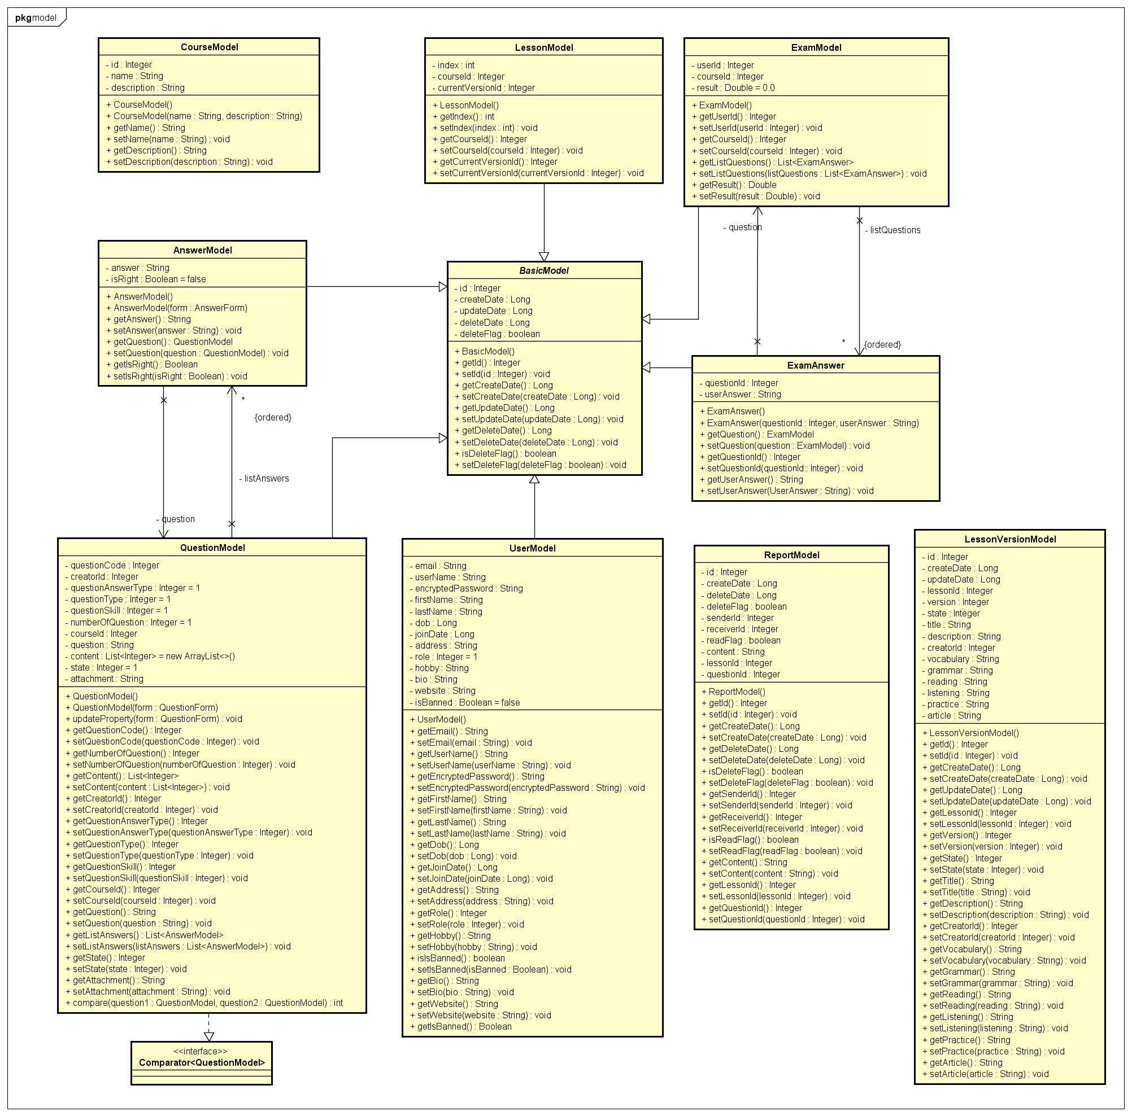

**Figure 6: Class diagram core.model package**

|  |  |  |
| --- | --- | --- |
| NNo | Class Name | Description |
| 1 | AnswerModel |  |
| 2 | BasicModel |  |
| 3 | CourseModel |  |
| 4 | ExamAnswer |  |
| 5 | ExamModel |  |
| 6 | LessonModel |  |
| 7 | LessonVersionModel |  |
| 8 | MessageModel |  |
| 9 | QuestionModel |  |
| 10 | ReportModel |  |
| 11 | UserModel |  |

### AnswerModel Class

#### Attributes

|  |  |  |  |  |  |
| --- | --- | --- | --- | --- | --- |
| No | Attribute | Type | Default | Note | Description |
| 1 | answer | String |  | private |  |
| 2 | isRight | Boolean |  | private |  |

#### Methods

|  |  |  |
| --- | --- | --- |
| No | Method | Description |
| 1 |  |  |

### BasicModel Class

#### Attributes

|  |  |  |  |  |  |
| --- | --- | --- | --- | --- | --- |
| No | Attribute | Type | Default | Note | Description |
| 1 | id | Integer |  | private |  |
| 2 | createDate | Long |  | private |  |
| 3 | updateDate | Long |  | private |  |
| 4 | deleteDate | Long |  | private |  |
| 5 | deleteFlag | Boolean |  | private |  |

#### Methods

|  |  |  |
| --- | --- | --- |
| No | Method | Description |
| 1 |  |  |

### CourseModel Class

#### Attributes

|  |  |  |  |  |  |
| --- | --- | --- | --- | --- | --- |
| No | Attribute | Type | Default | Note | Description |
| 1 | id | Integer |  | private |  |
| 2 | name | String |  | private |  |
| 3 | description | String |  | private |  |

#### Methods

|  |  |  |
| --- | --- | --- |
| No | Method | Description |
| 1 |  |  |

### ExamAnswer Class

#### Attributes

|  |  |  |  |  |  |
| --- | --- | --- | --- | --- | --- |
| No | Attribute | Type | Default | Note | Description |
| 1 | questionId | Integer |  | private |  |
| 2 | userAnswer | String |  | private |  |

#### Methods

|  |  |  |
| --- | --- | --- |
| No | Method | Description |
| 1 |  |  |

### ExamModel Class

#### Attributes

|  |  |  |  |  |  |
| --- | --- | --- | --- | --- | --- |
| No | Attribute | Type | Default | Note | Description |
| 1 | userId | Integer |  | private |  |
| 2 | courseId | Integer |  | private |  |
| 3 | result | Double |  | private |  |

#### Methods

|  |  |  |
| --- | --- | --- |
| No | Method | Description |
| 1 |  |  |

### LessonModel Class

#### Attributes

|  |  |  |  |  |  |
| --- | --- | --- | --- | --- | --- |
| No | Attribute | Type | Default | Note | Description |
| 1 | index | Integer |  | private |  |
| 2 | courseId | Integer |  | private |  |
| 3 | currentVersionId | Integer |  | private |  |

#### Methods

|  |  |  |
| --- | --- | --- |
| No | Method | Description |
| 1 |  |  |

### LessonVersionModel Class

#### Attributes

|  |  |  |  |  |  |
| --- | --- | --- | --- | --- | --- |
| No | Attribute | Type | Default | Note | Description |
| 1 | id | Integer |  | private |  |
| 2 | createDate | Long |  | private |  |
| 3 | updateDate | Long |  | private |  |
| 4 | lessonId | Integer |  | private |  |
| 5 | version | Integer |  | private |  |
| 6 | state | Integer |  | private |  |
| 7 | title | String |  | private |  |
| 8 | description | String |  | private |  |
| 9 | creatorId | Integer |  | private |  |
| 10 | vocabulary | String |  | private |  |
| 11 | grammar | String |  | private |  |
| 12 | reading | String |  | private |  |
| 13 | listening | String |  |  |  |
| 14 | practice | String |  |  |  |
| 15 | article | String |  |  |  |

#### Methods

|  |  |  |
| --- | --- | --- |
| No | Method | Description |
| 1 |  |  |

### MessageModel Class

#### Attributes

|  |  |  |  |  |  |
| --- | --- | --- | --- | --- | --- |
| No | Attribute | Type | Default | Note | Description |
| 1 | content | String |  | private |  |
| 2 | senderId | Integer |  | private |  |
| 3 | receiverId | Integer |  | private |  |
| 4 | readFlag | Boolean |  | private |  |

#### Methods

|  |  |  |
| --- | --- | --- |
| No | Method | Description |
| 1 |  |  |

### QuestionModel Class

#### Attributes

|  |  |  |  |  |  |
| --- | --- | --- | --- | --- | --- |
| No | Attribute | Type | Default | Note | Description |
| 1 | questionCode | Integer |  | private |  |
| 2 | creatorId | Integer |  | private |  |
| 3 | questionAnswerType | Integer |  | private |  |
| 4 | questionType | Integer |  | private |  |
| 5 | questionSkill | Integer |  | private |  |
| 6 | numberOfQuestion | Integer |  | private |  |
| 7 | courseId | Integer |  | private |  |
| 8 | question | String |  | private |  |
| 9 | content | List<Integer> |  | private |  |
| 10 | state | Integer |  | private |  |
| 11 | attachment | Integer |  | private |  |

#### Methods

|  |  |  |
| --- | --- | --- |
| No | Method | Description |
| 1 |  |  |

### ReportModel Class

#### Attributes

|  |  |  |  |  |  |
| --- | --- | --- | --- | --- | --- |
| No | Attribute | Type | Default | Note | Description |
| 1 | id | Integer |  | private |  |
| 2 | createDate | Long |  | private |  |
| 3 | deleteDate | Long |  | private |  |
| 4 | deleteFlag | Long |  | private |  |
| 5 | senderId | Integer |  | private |  |
| 6 | receiverId | Integer |  | private |  |
| 7 | readFlag | Boolean |  | private |  |
| 8 | content | String |  | private |  |
| 9 | lessonId | Integer |  | private |  |
| 10 | questionId | Integer |  | private |  |

#### Methods

|  |  |  |
| --- | --- | --- |
| No | Method | Description |
| 1 |  |  |

### UserModel Class

#### Attributes

|  |  |  |  |  |  |
| --- | --- | --- | --- | --- | --- |
| No | Attribute | Type | Default | Note | Description |
| 1 | email | String |  | private |  |
| 2 | userName | String |  | private |  |
| 3 | encryptedPassword | String |  | private |  |
| 4 | firstName | String |  | private |  |
| 5 | lastName | String |  | private |  |
| 6 | dob | Long |  | private |  |
| 7 | joinDate | Long |  | private |  |
| 8 | address | String |  | private |  |
| 9 | role | Integer |  | private |  |
| 10 | hobby | String |  | private |  |
| 11 | bio | String |  | private |  |
| 12 | website | String |  | private |  |
| 13 | quote | String |  |  |  |
| 14 | isBanned | Boolean |  |  |  |

#### Methods

|  |  |  |
| --- | --- | --- |
| No | Method | Description |
| 1 |  |  |

### Sequence Diagram

## core.response Package

### Class diagram

**Figure 7: Class diagram core.response package**

|  |  |  |
| --- | --- | --- |
| No | Class Name | Description |
| 1 | AddQuestionResponseData |  |
| 2 | AnswerResponseData |  |
| 3 | BriefLessonResponse |  |
| 4 | CreateLessonResponse |  |
| 5 | ExamResponseData |  |
| 6 | GetCourseResponse |  |
| 7 | GetLearnerExamsResponseData |  |
| 8 | GetLessonResponse |  |
| 9 | GetLessonVersionResponse |  |
| 10 | GetListUsersResponseData |  |
| 11 | GetQuestionDetailsResponseData |  |
| 12 | GetQuestionResponseData |  |
| 13 | GetUserResponseData |  |
| 14 | LoginResponseData |  |
| 15 | LookupWordResponse |  |
| 16 | Response |  |
| 17 | ResponseCode |  |
| 18 | ResponseExample |  |
| 19 | ResponseWordMean |  |
| 20 | UploadFileResponse |  |

### AddQuestionResponseData Class

#### Attributes

|  |  |  |  |  |  |
| --- | --- | --- | --- | --- | --- |
| No | Attribute | Type | Default | Note | Description |
| 1 | questionId | Integer |  | private |  |

#### Methods

|  |  |  |
| --- | --- | --- |
| No | Method | Description |
| 1 |  |  |

### AnswerResponseData Class

#### Attributes

|  |  |  |  |  |  |
| --- | --- | --- | --- | --- | --- |
| No | Attribute | Type | Default | Note | Description |
| 1 | answer | String |  | private |  |
| 2 | isRight | Boolean |  | private |  |

#### Methods

|  |  |  |
| --- | --- | --- |
| No | Method | Description |
| 1 |  |  |

### BriefLessonResponse Class

#### Attributes

|  |  |  |  |  |  |
| --- | --- | --- | --- | --- | --- |
| No | Attribute | Type | Default | Note | Description |
| 1 | lessonId | Integer |  | private |  |
| 2 | title | String |  | private |  |
| 3 | state | Integer |  | private |  |
| 4 | courseId | Integer |  | private |  |
| 5 | version | Integer |  | private |  |
| 6 | description | String |  | private |  |

#### Methods

|  |  |  |
| --- | --- | --- |
| No | Method | Description |
| 1 |  |  |

### CreateLessonResponse Class

#### Attributes

|  |  |  |  |  |  |
| --- | --- | --- | --- | --- | --- |
| No | Attribute | Type | Default | Note | Description |
| 1 | lessonId | Integer |  | private |  |
| 2 | courseId | Integer |  | private |  |
| 3 | version | Integer |  | private |  |
| 4 | lessonTitle | String |  | private |  |
| 5 | description | String |  | private |  |
| 6 | creatorId | Integer |  | private |  |
| 7 | createDate | Long |  | private |  |
| 8 | vocabulary | String |  | private |  |
| 9 | grammar | String |  | private |  |
| 10 | reading | String |  | private |  |
| 11 | listening | String |  | private |  |
| 12 | practice | String |  | private |  |
| 13 | article | String |  | private |  |

#### Methods

|  |  |  |
| --- | --- | --- |
| No | Method | Description |
| 1 |  |  |

### ExamResponseData Class

#### Attributes

|  |  |  |  |  |  |
| --- | --- | --- | --- | --- | --- |
| No | Attribute | Type | Default | Note | Description |
| 1 | examId | Integer |  | private |  |
| 2 | result | Double |  | private |  |

#### Methods

|  |  |  |
| --- | --- | --- |
| No | Method | Description |
| 1 |  |  |

### GetCourseResponse Class

#### Attributes

|  |  |  |  |  |  |
| --- | --- | --- | --- | --- | --- |
| No | Attribute | Type | Default | Note | Description |
| 1 | name | String |  | private |  |
| 2 | description | String |  | private |  |

#### Methods

|  |  |  |
| --- | --- | --- |
| No | Method | Description |
| 1 |  |  |

### GetLearnerExamsResponseData Class

#### Attributes

|  |  |  |  |  |  |
| --- | --- | --- | --- | --- | --- |
| No | Attribute | Type | Default | Note | Description |
| 1 | exams | ExamResponseData |  | private |  |

#### Methods

|  |  |  |
| --- | --- | --- |
| No | Method | Description |
| 1 |  |  |

### GetLessonResponse Class

#### Attributes

|  |  |  |  |  |  |
| --- | --- | --- | --- | --- | --- |
| No | Attribute | Type | Default | Note | Description |
| 1 | lessonId | Integer |  | private |  |
| 2 | courseId | Integer |  | private |  |
| 3 | lessonTitle | String |  | private |  |
| 4 | description | String |  | private |  |
| 5 | updateDate | Long |  | private |  |
| 6 | state | Integer |  | private |  |
| 7 | version | Integer |  | private |  |
| 8 | vocabulary | String |  | private |  |
| 9 | grammar | String |  | private |  |
| 10 | conversation | String |  | private |  |
| 11 | listening | String |  | private |  |
| 12 | practice | String |  | private |  |
| 13 | reading | String |  | private |  |
| 14 | previousLessonId | Integer |  | private |  |
| 15 | nextLessonId | Integer |  | private |  |

#### Methods

|  |  |  |
| --- | --- | --- |
| No | Method | Description |
| 1 |  |  |

### GetLessonVersionResponse Class

#### Attributes

|  |  |  |  |  |  |
| --- | --- | --- | --- | --- | --- |
| No | Attribute | Type | Default | Note | Description |
| 1 | lessonId | Integer |  | private |  |
| 2 | courseId | Integer |  | private |  |
| 3 | version | Integer |  | private |  |
| 4 | lessonTitle | String |  | private |  |
| 5 | description | String |  | private |  |
| 6 | creatorId | Integer |  | private |  |
| 7 | createDate | Long |  | private |  |
| 8 | updateDate | Long |  | private |  |
| 9 | vocabulary | String |  | private |  |
| 10 | grammar | String |  | private |  |
| 11 | reading | String |  | private |  |
| 12 | listening | String |  | private |  |
| 13 | practice | String |  | private |  |
| 14 | article | String |  | private |  |
| 15 | listVersions | List< Integer> |  | private |  |

#### Methods

|  |  |  |
| --- | --- | --- |
| No | Method | Description |
| 1 |  |  |

### GetListUsersResponseData Class

#### Attributes

|  |  |  |  |  |  |
| --- | --- | --- | --- | --- | --- |
| No | Attribute | Type | Default | Note | Description |
| 1 | listUsers | List<GetUserResponseData> |  | private |  |

#### Methods

|  |  |  |
| --- | --- | --- |
| No | Method | Description |
| 1 |  |  |

### GetQuestionDetailsResponseData Class

#### Attributes

|  |  |  |  |  |  |
| --- | --- | --- | --- | --- | --- |
| No | Attribute | Type | Default | Note | Description |
| 1 | numberOfQuestion | Integer |  | private |  |
| 2 | attachment | String |  | private |  |

#### Methods

|  |  |  |
| --- | --- | --- |
| No | Method | Description |
| 1 |  |  |

### GetQuestionResponseData Class

#### Attributes

|  |  |  |  |  |  |
| --- | --- | --- | --- | --- | --- |
| No | Attribute | Type | Default | Note | Description |
| 1 | questionId | Integer |  | private |  |
| 2 | questionCode | Integer |  | private |  |
| 3 | questionAnswerType | Integer |  | private |  |
| 4 | questionType | Integer |  | private |  |
| 5 | questionSkill | Integer |  | private |  |
| 6 | courseId | Integer |  | private |  |
| 7 | question | String |  | private |  |
| 8 | state | Integer |  | private |  |
| 9 | createDate | Long |  | private |  |
| 10 | updateDate | Long |  | private |  |

#### Methods

|  |  |  |
| --- | --- | --- |
| No | Method | Description |
| 1 |  |  |

### GetUserResponseData Class

#### Attributes

|  |  |  |  |  |  |
| --- | --- | --- | --- | --- | --- |
| No | Attribute | Type | Default | Note | Description |
| 1 | email | String |  | private |  |
| 2 | userName | String |  | private |  |
| 3 | firstName | String |  | private |  |
| 4 | lastName | String |  | private |  |
| 5 | dob | Long |  | private |  |
| 6 | joinDate | Long |  | private |  |
| 7 | address | String |  | private |  |
| 8 | role | Integer |  | private |  |
| 9 | hobby | String |  | private |  |
| 10 | bio | String |  | private |  |
| 11 | website | String |  | private |  |
| 12 | quote | String |  | private |  |

#### Methods

|  |  |  |
| --- | --- | --- |
| No | Method | Description |
| 1 |  |  |

### LoginResponseData Class

#### Attributes

|  |  |  |  |  |  |
| --- | --- | --- | --- | --- | --- |
| No | Attribute | Type | Default | Note | Description |
| 1 | role | Integer |  | private |  |

#### Methods

|  |  |  |
| --- | --- | --- |
| No | Method | Description |
| 1 |  |  |

### LookupWordResponse Class

#### Attributes

|  |  |  |  |  |  |
| --- | --- | --- | --- | --- | --- |
| No | Attribute | Type | Default | Note | Description |
| 1 | word | String |  | private |  |
| 2 | means | List<ResponseWordMean> |  | private |  |

#### Methods

|  |  |  |
| --- | --- | --- |
| No | Method | Description |
| 1 |  |  |

### Response Class

#### Attributes

|  |  |  |  |  |  |
| --- | --- | --- | --- | --- | --- |
| No | Attribute | Type | Default | Note | Description |
| 1 | code | Integer |  | private |  |
| 2 | data | String |  | private |  |

#### Methods

|  |  |  |
| --- | --- | --- |
| No | Method | Description |
| 1 |  |  |

### ResponseCode Class

#### Attributes

|  |  |  |  |
| --- | --- | --- | --- |
| No | Attribute | Type | Value |
| 1. 1 | SUCCESS | int | 200 |
| 1. 2 | CREATED | int | 201 |
| 1. 3 | FOUND | int | 302 |
| 1. 3 | BAD_REQUEST | int | 400 |
|  | UNAUTHORIZED | int | 401 |
|  | PERMISSION_DENIED | int | 403 |
|  | REQUEST_TIMEOUT | int | 408 |
|  | INVALID_EMAIL | int | 410 |
|  | DUPLICATED_EMAIL | int | 411 |
|  | EMAIL_NOT_FOUND | int | 412 |
|  | DUPLICATED_USERNAME | int | 413 |
|  | CORRUPTED_FORM | int | 460 |
|  | USERNAME_EXPECTED | int | 461 |
|  | PASSWORD_EXPECTED | int | 462 |
|  | EMAIL_EXPECTED | int | 463 |
|  | INVALID_PASSWORD | int | 420 |
|  | INCORRECT_PASSWORD | int | 421 |
|  | USER_NOT_FOUND | int | 430 |
|  | USER_NOT_ALLOW | int | 431 |
|  | USER_INACTIVE | int | 432 |
|  | USER_EXAMS_NOT_FOUND | int | 433 |
|  | USERNAME_PASSWORD_NOT_MATCH | int | 470 |
|  | PASSWORD_INCORRECT | int | 471 |
|  | QUESTION_NOT_FOUND | int | 440 |
|  | INTERNAL_SERVER_ERROR | int | 500 |
|  | UNSUPPORTED_API | int | 600 |

#### Methods

|  |  |  |
| --- | --- | --- |
| No | Method | Description |
| 1 |  |  |

### ResponseExample Class

#### Attributes

|  |  |  |  |  |  |
| --- | --- | --- | --- | --- | --- |
| No | Attribute | Type | Default | Note | Description |
| 1 | vi | String |  | private |  |
| 2 | ja | String |  | private |  |

#### Methods

|  |  |  |
| --- | --- | --- |
| No | Method | Description |
| 1 |  |  |

### ResponseWordMean Class

#### Attributes

|  |  |  |  |  |  |
| --- | --- | --- | --- | --- | --- |
| No | Attribute | Type | Default | Note | Description |
| 1 | kind | String |  | private |  |
| 2 | mean | String |  | private |  |

#### Methods

|  |  |  |
| --- | --- | --- |
| No | Method | Description |
| 1 |  |  |

### UploadFileResponse Class

#### Attributes

|  |  |  |  |  |  |
| --- | --- | --- | --- | --- | --- |
| No | Attribute | Type | Default | Note | Description |
| 1 | link | String |  | private |  |

#### Methods

|  |  |  |
| --- | --- | --- |
| No | Method | Description |
| 1 |  |  |

### Sequence Diagram

## core.security package

### Class diagram

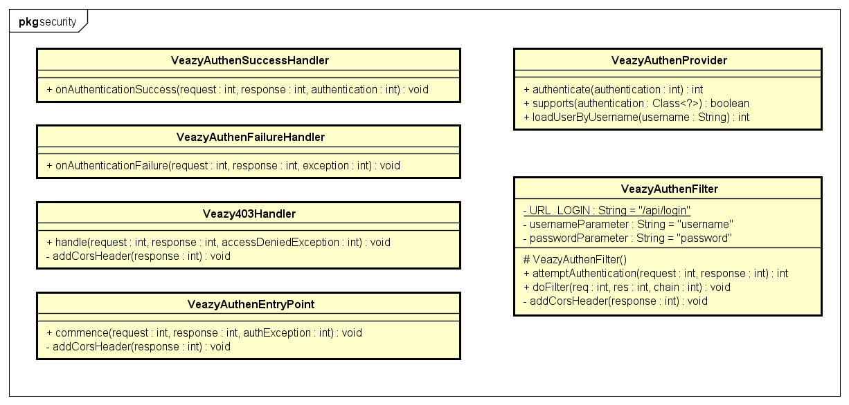

**Figure 8: Class diagram core.security package**

|  |  |  |
| --- | --- | --- |
| No | Class Name | Description |
| 1 | Veazy403Handler |  |
| 2 | VeazyAuthenEntryPoint |  |
| 3 | VeazyAuthenFailureHandler |  |
| 4 | VeazyAuthenFilter |  |
| 5 | VeazyAuthenProvider |  |
| 6 | VeazyAuthenSuccessHandler |  |

### Veazy403Handler Class

#### Attributes

|  |  |  |  |  |  |
| --- | --- | --- | --- | --- | --- |
| No | Attribute | Type | Default | Note | Description |
| 1 |  |  |  |  |  |

#### Methods

|  |  |  |
| --- | --- | --- |
| No | Method | Description |
| 1 | handle() |  |

### VeazyAuthenEntryPoint Class

#### Attributes

|  |  |  |  |  |  |
| --- | --- | --- | --- | --- | --- |
| No | Attribute | Type | Default | Note | Description |
| 1 |  |  |  |  |  |

#### Methods

|  |  |  |
| --- | --- | --- |
| No | Method | Description |
| 1 | commence() |  |

### VeazyAuthenFailureHandler Class

#### Attributes

|  |  |  |  |  |  |
| --- | --- | --- | --- | --- | --- |
| No | Attribute | Type | Default | Note | Description |
| 1 |  |  |  |  |  |

#### Methods

|  |  |  |
| --- | --- | --- |
| No | Method | Description |
| 1 | onAuthenticationFailure() |  |

### VeazyAuthenFilter Class

#### Attributes

|  |  |  |  |  |  |
| --- | --- | --- | --- | --- | --- |
| No | Attribute | Type | Default | Note | Description |
| 1 | URL_LOGIN | String |  | private |  |
| 2 | usernameParameter | String |  | private |  |
| 3 | passwordParameter | String |  | private |  |

#### Methods

|  |  |  |
| --- | --- | --- |
| No | Method | Description |
| 1 | attemptAuthentication() |  |
| 2 | doFilter() |  |
| 3 | addCorsHeader() |  |

### VeazyAuthenProvider Class

#### Attributes

|  |  |  |  |  |  |
| --- | --- | --- | --- | --- | --- |
| No | Attribute | Type | Default | Note | Description |
| 1 |  |  |  |  |  |

#### Methods

|  |  |  |
| --- | --- | --- |
| No | Method | Description |
| 1 | authenticate() |  |
| 2 | supports() |  |
| 3 | loadUserByUsername() |  |

### VeazyAuthenSuccessHandler Class

#### Attributes

|  |  |  |  |  |  |
| --- | --- | --- | --- | --- | --- |
| No | Attribute | Type | Default | Note | Description |
| 1 |  |  |  |  |  |

#### Methods

|  |  |  |
| --- | --- | --- |
| No | Method | Description |
| 1 | onAuthenticationSuccess() |  |

### Sequence Diagram

## core.service Package

### Class diagram

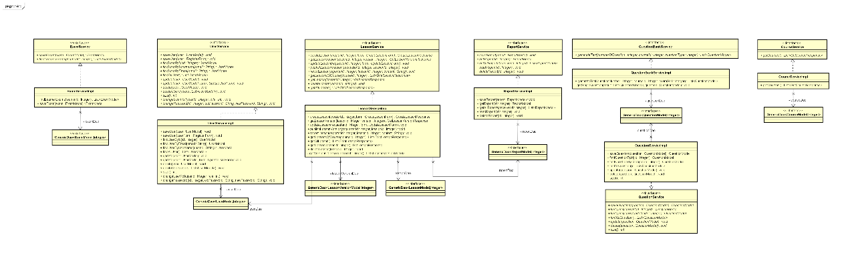

**Figure 9: Class diagram core.service package**

|  |  |  |
| --- | --- | --- |
| No | Class Name | Description |
| 1 | CourseServiceImpl |  |
| 2 | ExamServiceImpl |  |
| 3 | LessonServiceImpl |  |
| 4 | QuestionBankServiceImpl |  |
| 5 | QuestionServiceImpl |  |
| 6 | ReportServiceImpl |  |
| 7 | UserServiceImpl |  |

### CourseServiceImpl Class

#### Attributes

|  |  |  |  |  |  |
| --- | --- | --- | --- | --- | --- |
| No | Attribute | Type | Default | Note | Description |
| 1 |  |  |  | private |  |

#### Methods

|  |  |  |
| --- | --- | --- |
| No | Method | Description |
| 1 | getCourses() |  |

### ExamServiceImpl Class

#### Attributes

|  |  |  |  |  |  |
| --- | --- | --- | --- | --- | --- |
| No | Attribute | Type | Default | Note | Description |
| 1 |  |  |  | private |  |

#### Methods

|  |  |  |
| --- | --- | --- |
| No | Method | Description |
| 1 | findLearnerExams |  |
| 2 | saveExam |  |

### LessonServiceImpl Class

#### Attributes

|  |  |  |  |  |  |
| --- | --- | --- | --- | --- | --- |
| No | Attribute | Type | Default | Note | Description |
| 1 |  |  |  | private |  |

#### Methods

|  |  |  |
| --- | --- | --- |
| No | Method | Description |
| 1 | createLesson() |  |
| 2 | getLessonVersion() |  |
| 3 | updateLesson() |  |
| 4 | publishLessonVersion() |  |
| 5 | reportLesson() |  |
| 6 | getLessonsOfCourse() |  |
| 7 | getLesson() |  |
| 8 | deleteLesson() |  |
| 9 | getAllLesson() |  |

### QuestionBankServiceImpl Class

#### Attributes

|  |  |  |  |  |  |
| --- | --- | --- | --- | --- | --- |
| No | Attribute | Type | Default | Note | Description |
| 1 |  |  |  | private |  |

#### Methods

|  |  |  |
| --- | --- | --- |
| No | Method | Description |
| 1 | generateTest() |  |
| 2 | getSingleQuestion() |  |

### QuestionServiceImpl Class

#### Attributes

|  |  |  |  |  |  |
| --- | --- | --- | --- | --- | --- |
| No | Attribute | Type | Default | Note | Description |
| 1 |  |  |  | private |  |

#### Methods

|  |  |  |
| --- | --- | --- |
| No | Method | Description |
| 1 | saveQuestion() |  |
| 2 | findQuestionById() |  |
| 3 | findQuestionByCode() |  |
| 4 | findAllQuestion() |  |
| 5 | update() |  |
| 6 | delete() |  |
| 7 | size() |  |

### ReportServiceImpl Class

#### Attributes

|  |  |  |  |  |  |
| --- | --- | --- | --- | --- | --- |
| No | Attribute | Type | Default | Note | Description |
| 1 |  |  |  | private |  |

#### Methods

|  |  |  |
| --- | --- | --- |
| No | Method | Description |
| 1 | saveReport() |  |
| 2 | getReport() |  |
| 3 | getAllReports() |  |
| 4 | readReport() |  |
| 5 | deleteReport() |  |

### UserServiceImpl Class

#### Attributes

|  |  |  |  |  |  |
| --- | --- | --- | --- | --- | --- |
| No | Attribute | Type | Default | Note | Description |
| 1 |  |  |  | private |  |

#### Methods

|  |  |  |
| --- | --- | --- |
| No | Method | Description |
| 1 | saveUser() |  |
| 2 | saveUser() |  |
| 3 | findUserById() |  |
| 4 | findUserByEmail() |  |
| 5 | findUserByUsername() |  |
| 6 | findAllUser() |  |
| 7 | update() |  |
| 8 | update() |  |
| 9 | delete() |  |
| 10 | deleteUsers() |  |
| 11 | size() |  |
| 12 | changeUserRoll() |  |
| 13 | changePassword() |  |

## dictionary.controller Package

### D:\Documents\GitHub\DATN\201605JS01\WIP\Users\TungDT\Class Diagram\Dict Controller.pngClass diagram

**Figure 10: Class diagram dictionary.controller package**

|  |  |  |
| --- | --- | --- |
| No | Class Name | Description |
| 1 | DictController |  |

### DictController Class

#### Attributes

|  |  |  |  |  |  |
| --- | --- | --- | --- | --- | --- |
| No | Attribute | Type | Default | Note | Description |
| 1 |  |  |  |  |  |

#### Methods

|  |  |  |
| --- | --- | --- |
| No | Method | Description |
| 1 | lookupJavi() |  |
| 2 | lookupVija() |  |

### Sequence Diagram

## dictionary.dao Package

### Class diagram

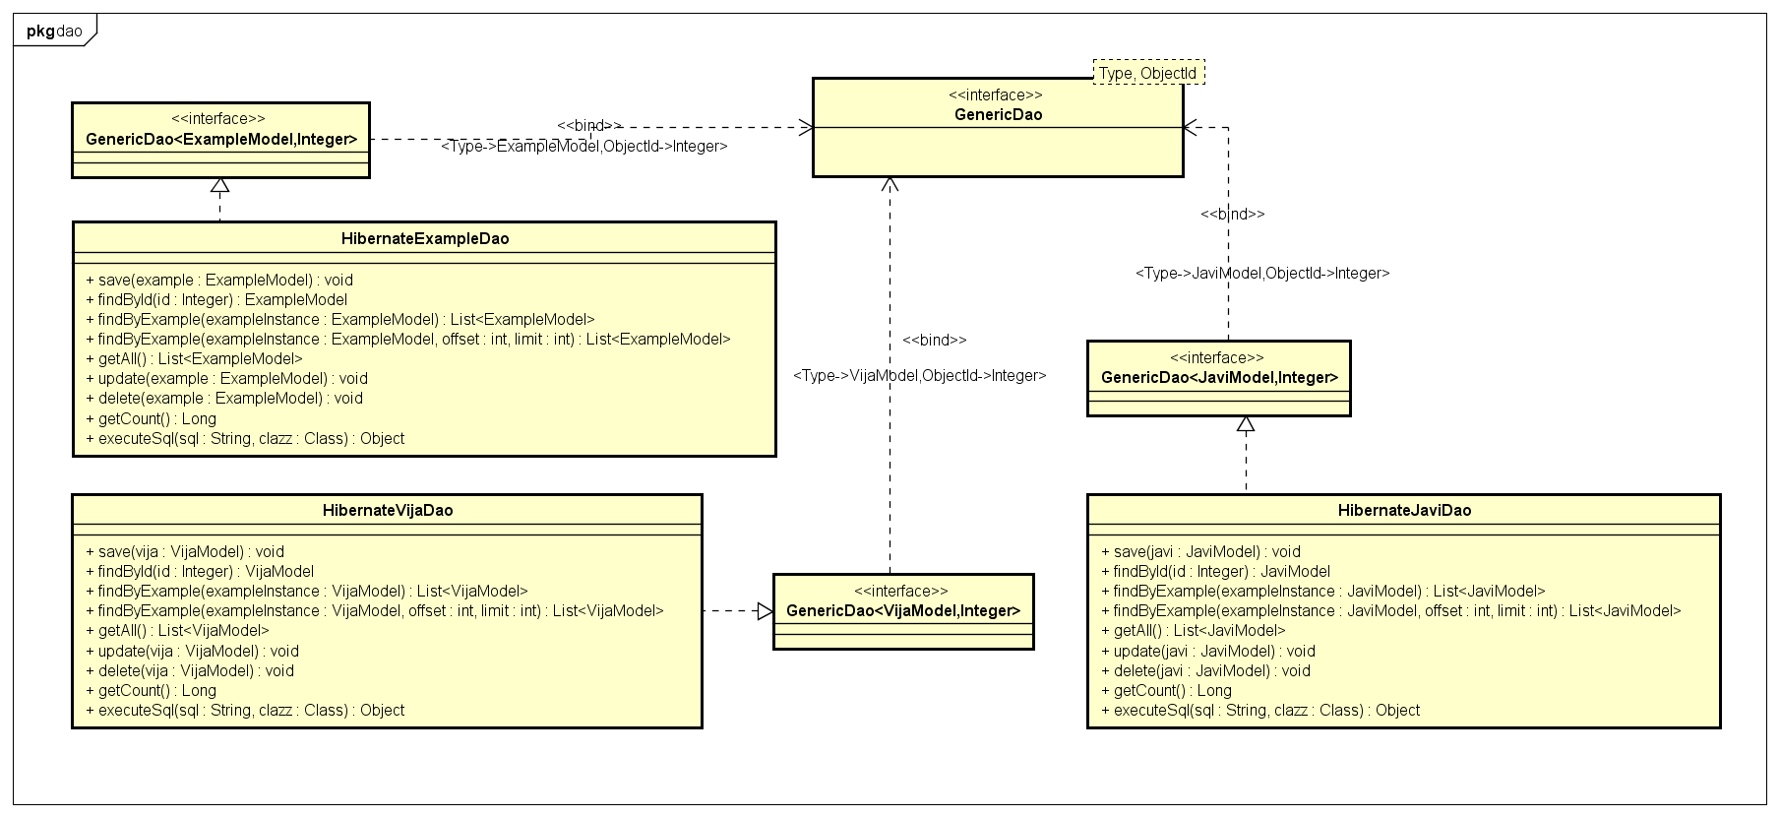

**Figure 11: Class diagram dictionary.dao package**

|  |  |  |
| --- | --- | --- |
| No | Class Name | Description |
| 1 | HibernateExampleDao |  |
| 2 | HibernateJaviDao |  |
| 3 | HibernateVijaDao |  |

### HibernateExampleDao Class

#### Attributes

|  |  |  |  |  |  |
| --- | --- | --- | --- | --- | --- |
| No | Attribute | Type | Default | Note | Description |
| 1 |  |  |  |  |  |

#### Methods

|  |  |  |
| --- | --- | --- |
| No | Method | Description |
| 1 | save() |  |
| 2 | findById() |  |
| 3 | findByExample() |  |
| 4 | findByExample() |  |
| 5 | getAll() |  |
| 6 | update() |  |
| 7 | delete() |  |
| 8 | getCount() |  |
| 9 | executeSql() |  |

### HibernateJaviDao Class

#### Attributes

|  |  |  |  |  |  |
| --- | --- | --- | --- | --- | --- |
| No | Attribute | Type | Default | Note | Description |
| 1 |  |  |  |  |  |

#### Methods

|  |  |  |
| --- | --- | --- |
| No | Method | Description |
| 1 | save() |  |
| 2 | findById() |  |
| 3 | findByExample() |  |
| 4 | findByExample() |  |
| 5 | getAll() |  |
| 6 | update() |  |
| 7 | delete() |  |
| 8 | getCount() |  |
| 9 | executeSql() |  |

### HibernateVijaDao Class

#### Attributes

|  |  |  |  |  |  |
| --- | --- | --- | --- | --- | --- |
| No | Attribute | Type | Default | Note | Description |
| 1 |  |  |  |  |  |

#### Methods

|  |  |  |
| --- | --- | --- |
| No | Method | Description |
| 1 | save() |  |
| 2 | findById() |  |
| 3 | findByExample() |  |
| 4 | findByExample() |  |
| 5 | getAll() |  |
| 6 | update() |  |
| 7 | delete() |  |
| 8 | getCount() |  |
| 9 | executeSql() |  |

### Sequence Diagram

## dictionary.model package

### Class diagram

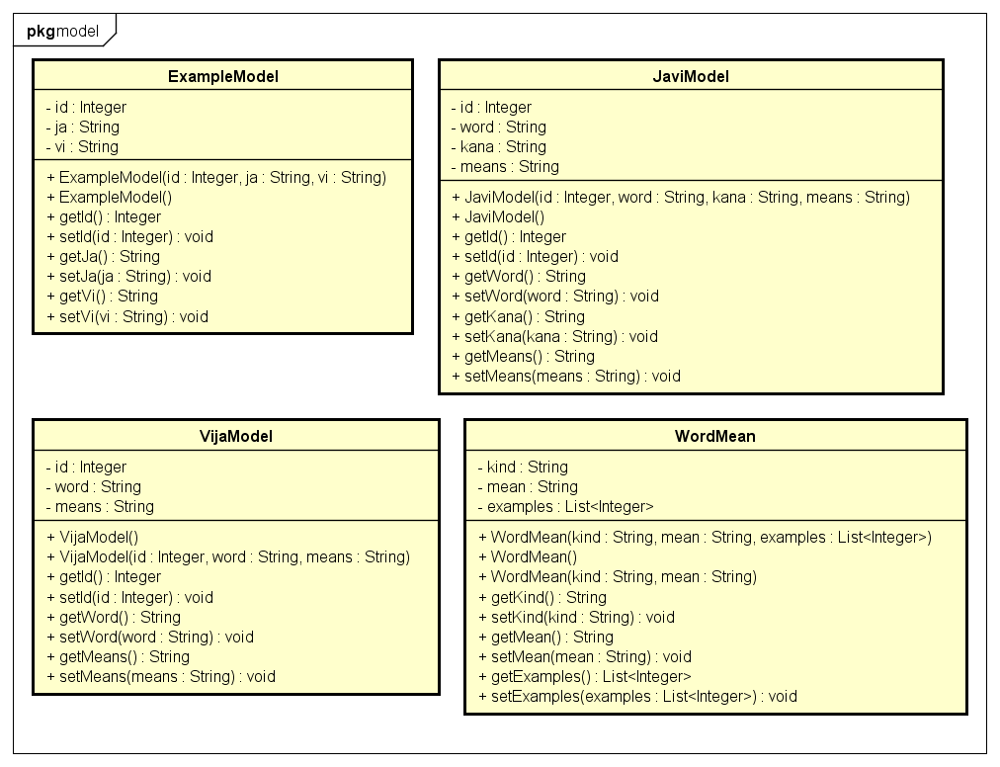

**Figure 7: Class diagram dictionary.model package**

|  |  |  |
| --- | --- | --- |
| No | Class Name | Description |
| 1 | ExampleModel |  |
| 2 | JaviModel |  |
| 3 | VijaModel |  |
| 4 | WordMean |  |

### ExampleModel Class

#### Attributes

|  |  |  |  |  |  |
| --- | --- | --- | --- | --- | --- |
| No | Attribute | Type | Default | Note | Description |
| 1 | id | Integer |  | private |  |
| 2 | ja | String |  | private |  |
| 3 | vi | String |  | private |  |

#### Methods

|  |  |  |
| --- | --- | --- |
| No | Method | Description |
| 1 |  |  |

### JaviModel Class

#### Attributes

|  |  |  |  |  |  |
| --- | --- | --- | --- | --- | --- |
| No | Attribute | Type | Default | Note | Description |
| 1 | id | Integer |  | private |  |
| 2 | word | String |  | private |  |
| 3 | kana | String |  | private |  |
| 4 | means | String |  | private |  |

#### Methods

|  |  |  |
| --- | --- | --- |
| No | Method | Description |
| 1 |  |  |

### VijaModel Class

#### Attributes

|  |  |  |  |  |  |
| --- | --- | --- | --- | --- | --- |
| No | Attribute | Type | Default | Note | Description |
| 1 | id | Integer |  | private |  |
| 2 | word | String |  | private |  |
| 3 | means | String |  | private |  |

#### Methods

|  |  |  |
| --- | --- | --- |
| No | Method | Description |
| 1 |  |  |

### WordMean Class

#### Attributes

|  |  |  |  |  |  |
| --- | --- | --- | --- | --- | --- |
| No | Attribute | Type | Default | Note | Description |
| 1 | kind | String |  | private |  |
| 2 | mean | String |  | private |  |
| 3 | examples | List<Integer> |  | private |  |

#### Methods

|  |  |  |
| --- | --- | --- |
| No | Method | Description |
| 1 |  |  |

### Sequence Diagram

## dictionary.service package

### Class diagram

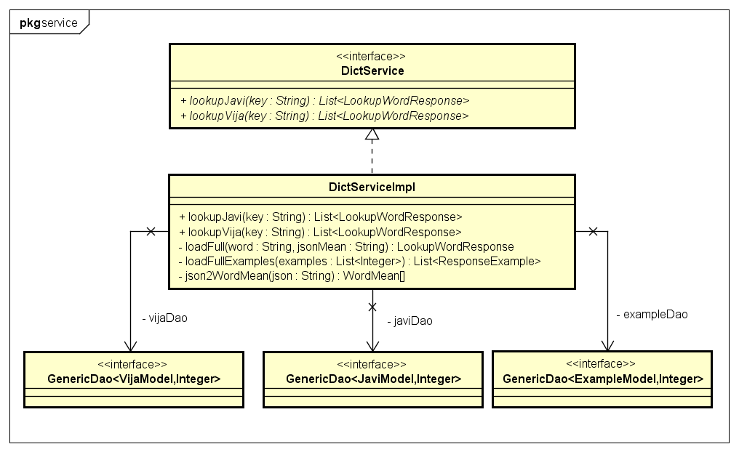

**Figure 7: Class diagram dictionary.service package**

|  |  |  |
| --- | --- | --- |
| No | Class Name | Description |
| 1 | DictServiceImpl |  |

### DictServiceImpl Class

#### Attributes

|  |  |  |  |  |  |
| --- | --- | --- | --- | --- | --- |
| No | Attribute | Type | Default | Note | Description |
| 1 |  |  |  |  |  |

#### Methods

|  |  |  |
| --- | --- | --- |
| No | Method | Description |
| 1 | lookupJavi() |  |
| 2 | lookupVija() |  |
| 3 | loadFull() |  |
| 4 | loadFullExamples() |  |
| 5 | json2WordMean() |  |

### Sequence Diagram

# MVC model

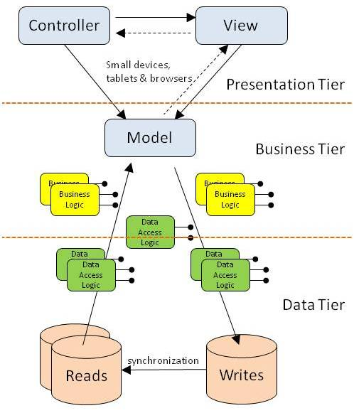

***Figure 6: MVC Model***